CMS Dance Program T-Shirt Fundraiser
Please support Volusia County Performing Arts. Choose one of the following T-Shirts to help raise funds for Creekside Middle School dance program equipment, costumes, dance shoes, and guest master choreographers. Thank you so much. Every little bit counts. Please make checks payable to “Creekside Middle School” or send Cash in an envelope. ~ CMS Dance
ALL SHIRTS WILL COME IN FOREST GREEN WITH WHITE & BLACK DESIGN
Available in Youth XS, YS, YM, YL, YXL, Adult S, AM, AL, AXL, and Plus 2XL, 3XL & 4XL
T- Shirt Design | Cost | T-Shirt Design | Cost
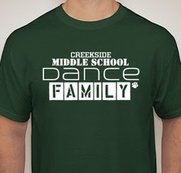 | #1  $15 | 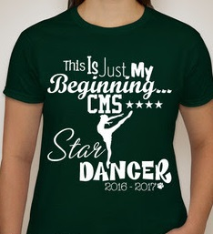 | #2  $15
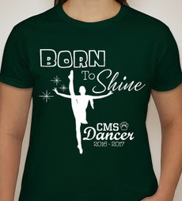 | #3  $15 | 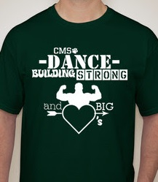 | #4  $15

Money and orders due September 16, 2016 to Ms. Wade at Creekside Middle School

PLEASE DO NOT FILL THIS PAGE OUT – For Ms. Wade Only
T-Shirt Order Summary Forms – CMS Dance 2014
Dancer / Student _______________________________________________________________________
Design #1 ($15) Total # of Shirts: ____________ times $15 = Total Cost ___________________ Teacher Initial ____
YXS __________ YS_______________ YM ________________ YL ______________ YXL ___________
AS ___________ AM ______________ AL _________________ AXL _______________
2XL ________________ 3XL ____________________ 4XL ___________________
Design #2 ($15) Total # of Shirts: ____________ times $15 = Total Cost ___________________ Teacher Initial ____
YXS __________ YS_______________ YM ________________ YL ______________ YXL ___________
AS ___________ AM ______________ AL _________________ AXL _______________
2XL ________________ 3XL ____________________ 4XL ___________________
Design #3 ($15) Total # of Shirts: ____________ times $15 = Total Cost ___________________ Teacher Initial ____
YXS __________ YS_______________ YM ________________ YL ______________ YXL ___________
AS ___________ AM ______________ AL _________________ AXL _______________
2XL ________________ 3XL ____________________ 4XL ___________________
Design #4 ($15) Total # of Shirts: ____________ times $15 = Total Cost ___________________ Teacher Initial ____
YXS __________ YS_______________ YM ________________ YL ______________ YXL ___________
AS ___________ AM ______________ AL _________________ AXL _______________
2XL ________________ 3XL ____________________ 4XL ___________________

CMS Dance Program T-Shirt Fundraiser Order Form
All orders and funds are due September 16, 2016. Please do not turn in anything early Thank you!
*For multiple designs per person, please use additional lines. Please see the *Sample*
First Name | Last Name | Best Contact Information | Design Number | Size | Quantity  (How Many) | Cost | Paid
*Sample*  Noelle | Wade | (555) 555-5555 / or / NoelleWade.55@gmail.com | #2 | L | 1 | $15
Noelle | Wade |  | #3 | M | 1 | $15
Noelle | Wade |  | #1 | S | 1 | $15 | $45

CMS Dance Program T-Shirt Fundraiser Order Form
All orders and funds are due September 30, 2016. Please do not turn in anything early Thank you!
*For multiple designs per person, please use additional lines. Please see the *Sample*
First Name | Last Name | Best Contact Information | Design Number | Size | Quantity  (How Many) | Cost | Paid
*Sample*  Noelle | Wade | (555) 555-5555 / or / NoelleWade.55@gmail.com | #2 | L | 1 | $15
Noelle | Wade |  | #3 | M | 1 | $15
Noelle | Wade |  | #1 | S | 1 | $15 | $45

