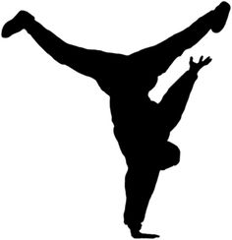Cougarettes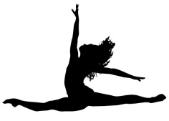
Congratulations on making your first performance memorable! I’m very proud of you all! Let’s work hard in class and at practice to make sure our next performance is even stronger! Please make sure to attend the following practices to prepare for our next two appearances:
** October 27, 28 and 30, November 3,4, 6 and 7th : 3:45 – 5 pm
** Prepare to return to school at 5:00 pm October 10, for our Veterans Day performance at 6 pm. The event should last until no later than 8 pm.
** Plan to have a dress rehearsal for Volusia County Dances on November 12 from 2:45 – 5 pm. Another flyer with details for drop offs and pick ups is in the making.
** VCD performance flyer is attached. Please give the business partner flyer to a locally owned business to help raise funds for Florida Camp for Children and Youth With Diabetes. Please ask for the name of the owner and contact number or email so I can follow up with them. If you would, please visit in your Cougarette Parade attire. This will kick start our community service for the holiday season.
** If anyone has an idea of where to contribute to the local community, please let me know ASAP. I’d like to organize and schedule to help at a soup kitchen, food pantry, or to perform at a nursing home or children’s hospital. Let me know if you have any ideas. I believe someone gave me a great idea, and it has escaped my memory I can do some research, but if any cause is near and dear to any of our Cougarette families hearts, let’s do something meaningful .
Bring water to practice and return dance shoes between performances, please. Only two dancers have returned their dance sneakers, and although you may use them for the remainder of the year, they officially belong to the CMS Dance Program. Let’s make sure to respect those that fund raised for them in the past. Call or email me with any questions, concerns, or suggestions. CMSCougarsDance@gmail.com Thank you especially to all of the families who continue to make this a great experience!! ~ Coach Adriana ~

